**PRACTICAL NOTEBOOK**

**2021 -2022**

**Arnav Suman**

**12 C**

**TERM 2**

**TERM-2**

37. WAP to enter N elements of integer type in a Linear List and sort the elements using

1) Bubble Sort

2) Selection Sort

38. WAP to enter N elements of integer type in a Linear List and an element of integer type and check whether the list contains that element or not

39. WAP to enter N elements of integer type in a Linear List and an element of integer type and count the occurrence of the element

40. WAP to enter N elements in a List and insert an element at a specific position

41. WAP to enter N sorted elements and insert an element at appropriate position

42. WAP to enter N element in a List and delete an element

43. WAP to delete all the occurrence of the number in a listP to create a 2D Linear List (input and output all the elements in 2D List.

44. Write a menu driven program to perform the following operations in a Linear List

using Stack.

1.Push

2.Pop

3.Display

4. Count

5. Exit

45. Write a python program to check whether a string is a palindrome or not

using stack.

46.. Write a program to implement all stack operations (push,pop,peek ) for

the employee details (empno, name).

47.. Create the database product and then create the following  table item in it.

Column name Data type Size Constrain

 Itemno Number 3 Primary key

  Iname Varchar 15

  Price Number 10,2

  Quantity Number   3

48. Insert the following information in the above table :

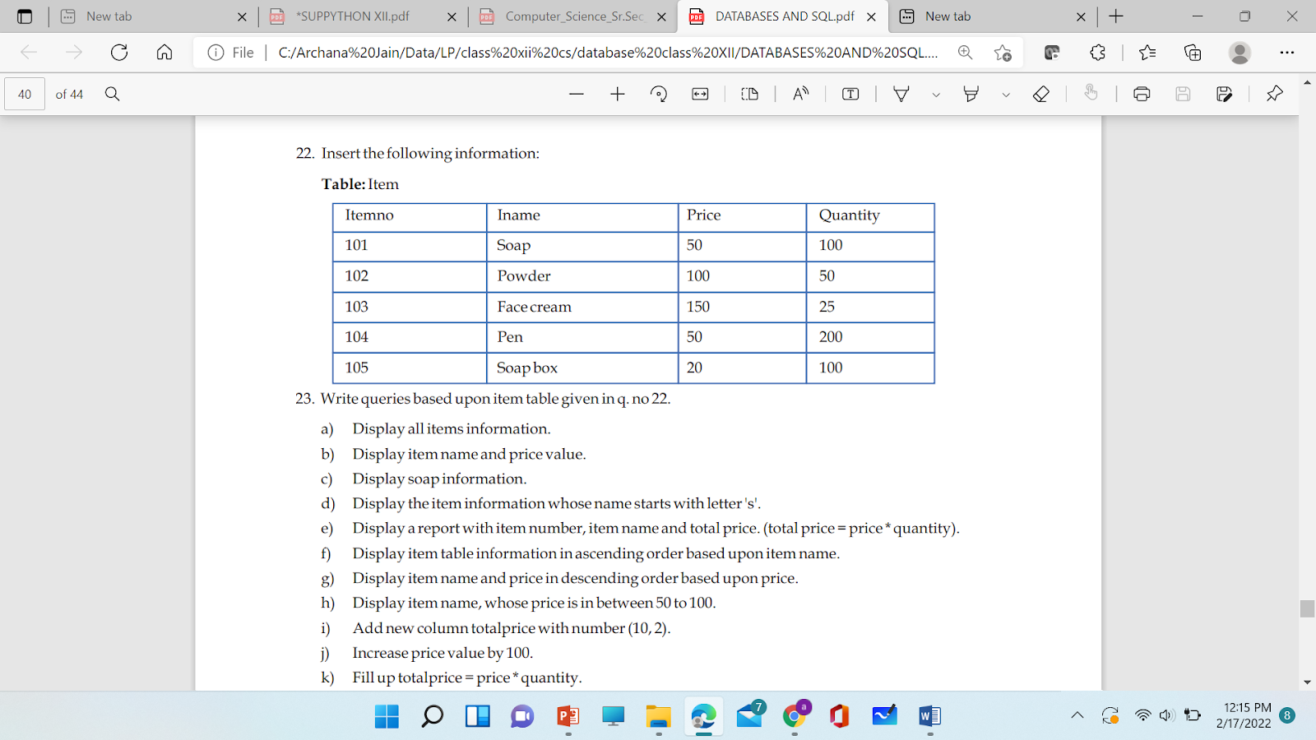

49. Write the following queries based on the above item table :

1. Display all items information.
2. Display item name and price value.
3. Display soap information.
4. Display the item information whose name starts with letter 's'.
5. Display a report with item number, item name and total price. (total price = price * quantity).
6. Display item table information in ascending order based upon item name.
7. Display item name and price in descending order based upon price.
8. Display item name, whose price is in between 50 to 100.
9. To decrease price value by 5%.

50. Write the following queries based on the above item table :

1. Add new column totalprice with number (10, 2).
2. Alter the data type of iname as varchar(25)
3. Fill up totalprice = price * quantity.
4. Display the item with maximum Price
5. Remove powder information.
6. Remove totalprice column.
7. Remove whole item table structure.
8. Remove the database product

51. Write outputs based upon item table

1. select sum(price) from item;

2.        select avg(price) from item;

3. select min(price) from item;

4. select max(price) from item; 5.

5. select count(price) from item;

6. select distinct price from item;

7.        select count(distinct price) from item

8. select iname,price*quantity from item

52.     In a database product their are two tables , Write the following Queries :

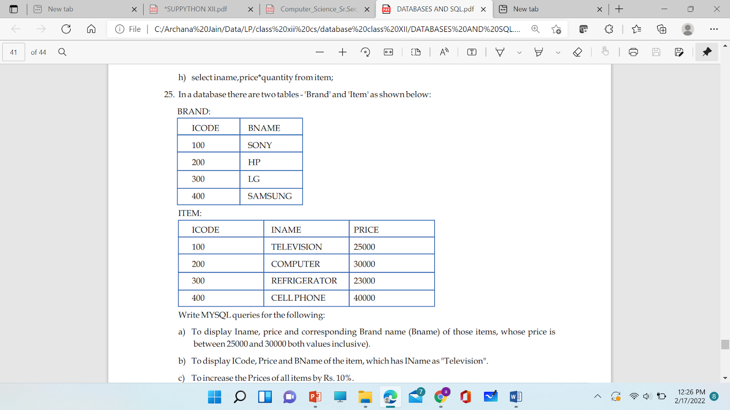

Write MYSQL queries for the following:

 a) To display Iname, price and corresponding Brand name (Bname) of those items, whose price is between 25000 and 30000 both values inclusive).

 b) To display ICode, Price and BName of the item, which has IName as "Television".

c) To increase the Prices of all items by Rs. 10%.

d) To display different unique brand names of all products.

53. Create the table Students with the following specifications :

 Column name Data type Size Constraints

  Adno Integer 3 Primary key

  Name Varchar 20

Average Integer 3

Gender Char 1

Scode Integer 4

54. Insert the following information in the above student table:

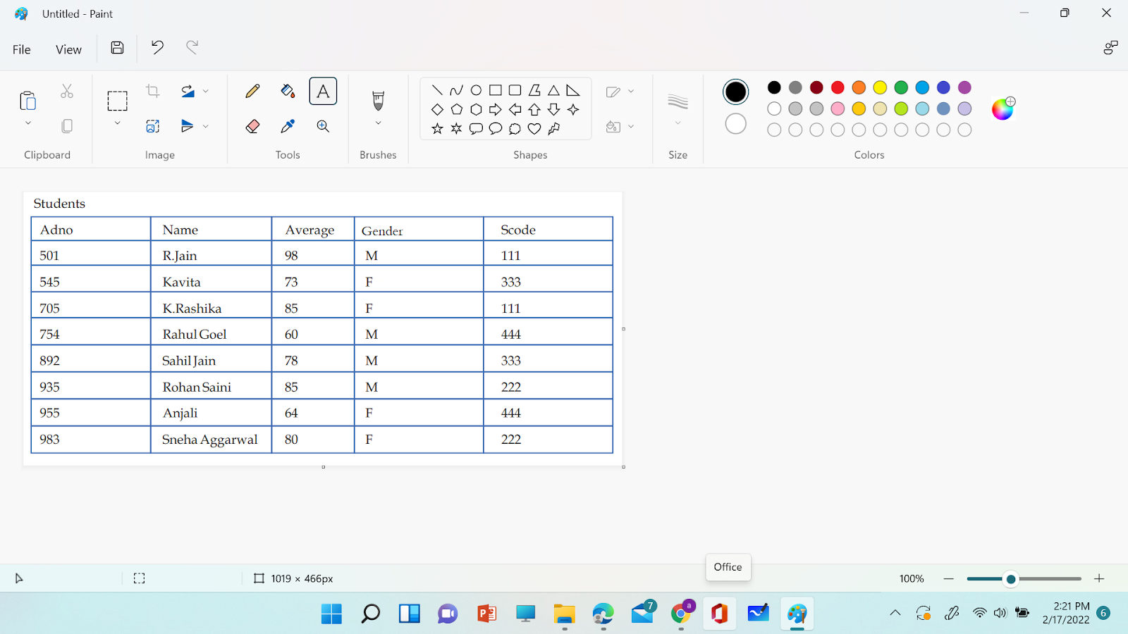

55 Write queries based upon above student table.

 (i) Display all students' information.

(ii) Display Rohan Saini's information.

(iii) Display number of students in the table.

(iv) Display number of students in each gender.

(v) Display students' information in ascending order using name.

(vi) Display students' information in descending order using average marks.

(vii) Display students' name starting with letter "K".

(viii) Display students' information, whose name ends with "l".

(ix) Display a report with adno,name,average*5 as total marks from student table.

(x) Display students' information, whose average marks are in between 80 to 90.

56. Write queries based upon above student table.

(i) Display students' info., who are getting average marks of more than 80 and

           scode 333.

(ii) Display students' name and average marks, whose scode is 222 and 333.

(iii) Display sum of average marks.

(iv) Display maximum average marks

(v) Display minimum average marks.

(vi) Display average marks for each gender.

(vii) Display maximum, minimum and sum of average marks in each scode.

(viii) Display number of students in each scode

57. **. Write the SQL commands for (i) to (v) on the basis of tables following table:**

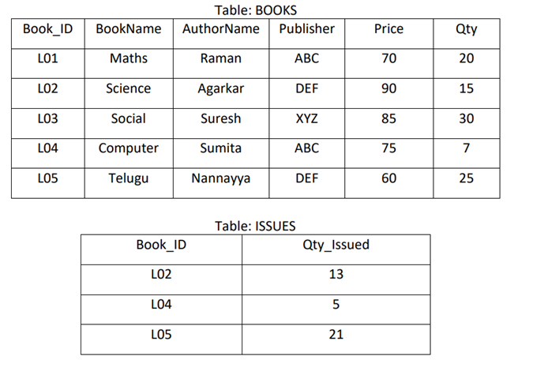

(i) To show Book name, Author name and Price of books of ABC publisher.

(ii) To display the details of the books in descending order of their price.

(iii) To display the Book Id, Book name, Publisher, Price, Qty, Qty_Issued from both the tables with

their matching Book ID.

(iv) Display minimum price of each publisher with their name.

(v) Display the price of only those books where Qty_issued is 5.

58

Write a menu based program to perform the following operation on Customer Details using Interfacing Python with MySQL

1. Add new record

2. Display all the record

3. Search record based on Cust_Id

Customer table has following structure

Cust_id Integer Type

Cust_name varchar Thpe

Cust_age Integer Type

DOB date Type

Outstanding Amount float type

59.

Write a menu based program to perform the following operation on Customer Details using Interfacing Python with MySQL

1. Update a record based on Cust_id

2. Delete  record based on Cust_Id

3. Display all the record

Customer table has following structure

Cust_id Integer Type

Cust_name varchar Type

Cust_age Integer Type

DOB date Type

Outstanding Amount float type

60 Write a MySQL connectivity program in Python to Create a database school and then create Create a table book with the specifications – Book_id , book_title, Author , Price , Qty , and perform the following operations:

1. Create a table
2. Add a record
3. Search a record
4. Update a record
5. Delete a record
6. Display all records
7. Exit

Perform all the operations with reference to table ‘book’ through MySQL-Python connectivity..

**PRACTICAL 37**

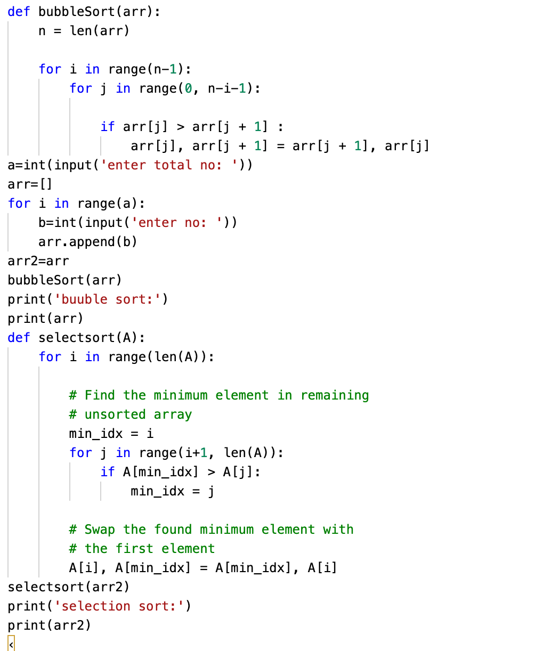

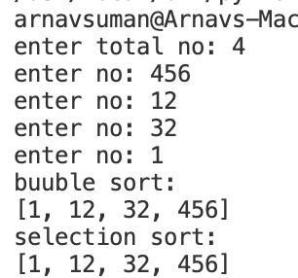

**PRACTICAL 38**

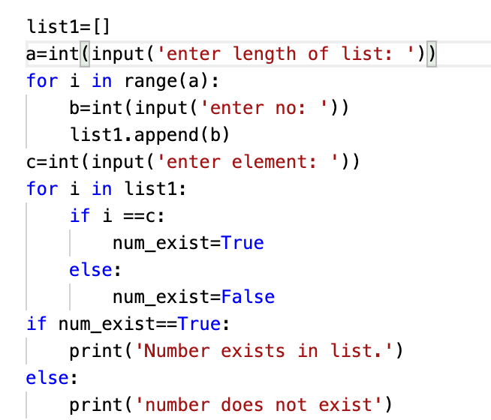

**OUTPUT**

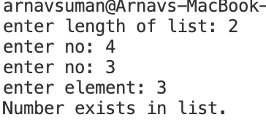

**PRACTICAL 39**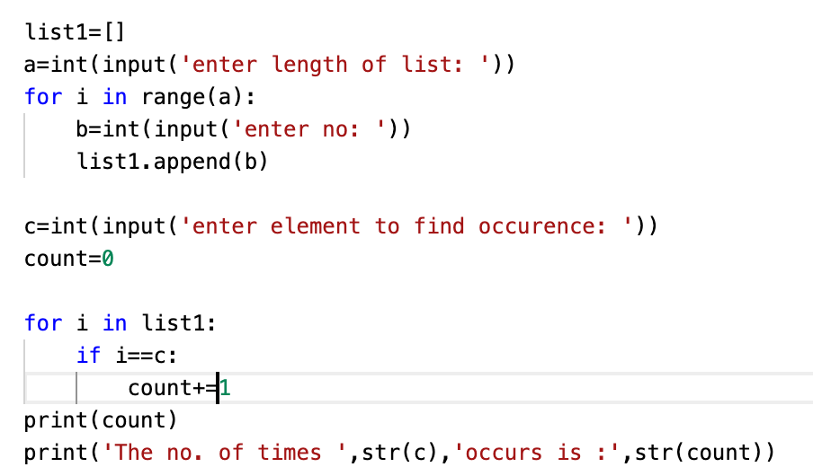

**OUTPUT**

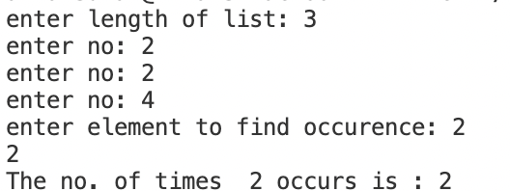

**PRACTICAL 40**

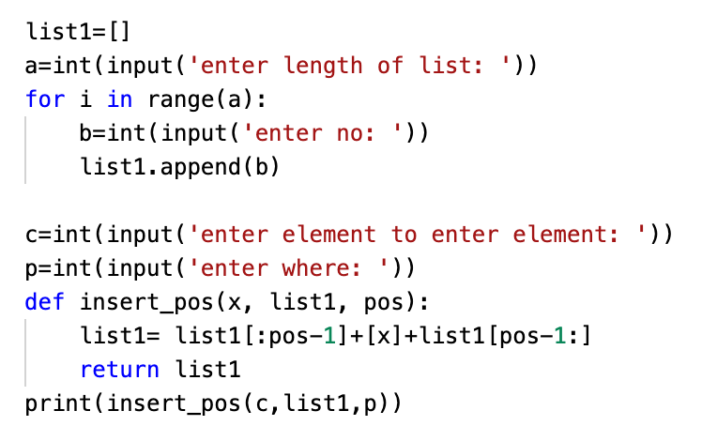

**OUTPUT**



**PRACTICAL 41**

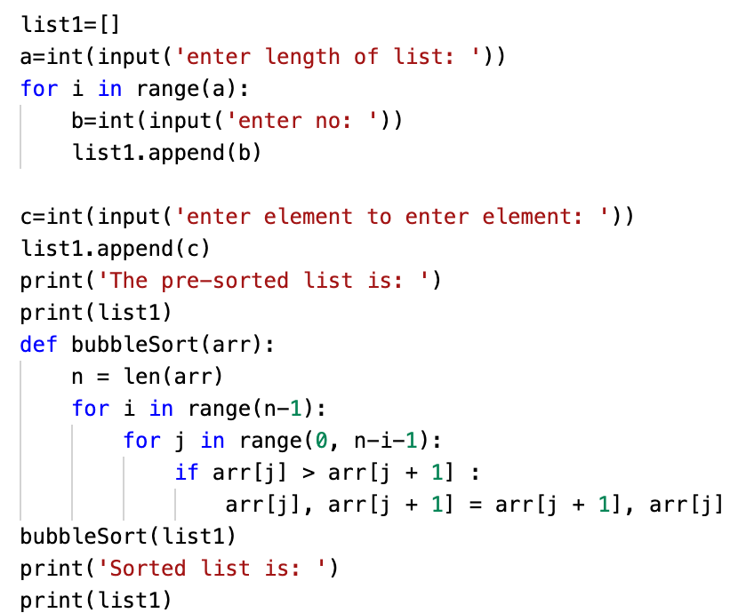

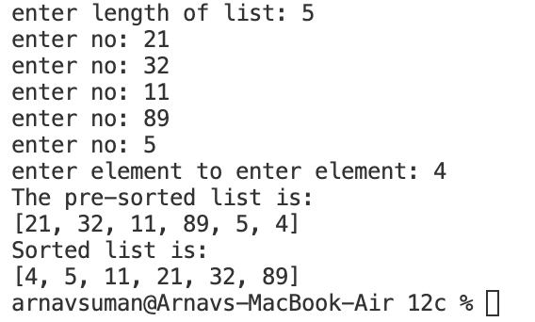

**PRACTICAL 42**

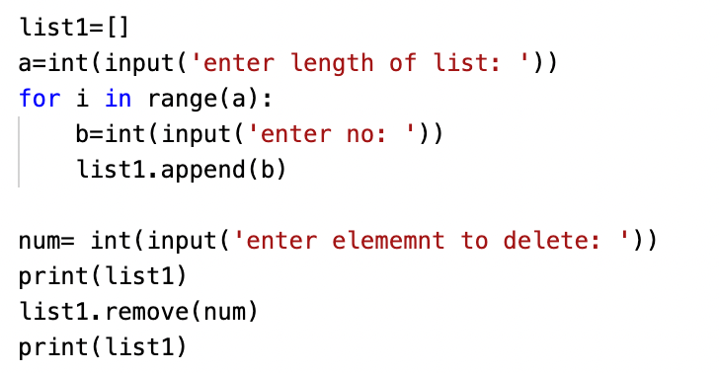

**OUTPUT**

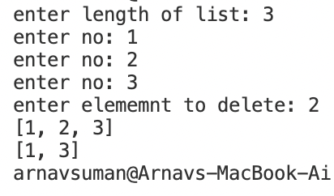

**PRACTICAL 43**

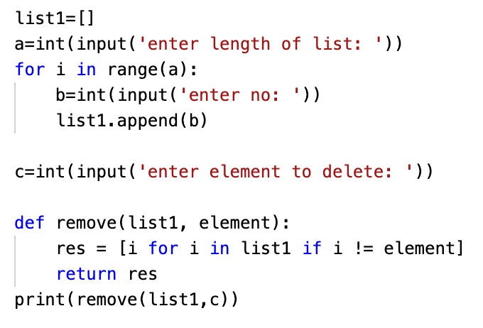

**OUTPUT**

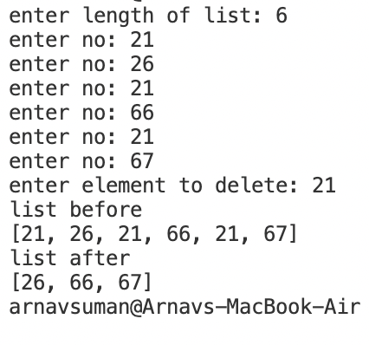

**PRACTICAL 44**

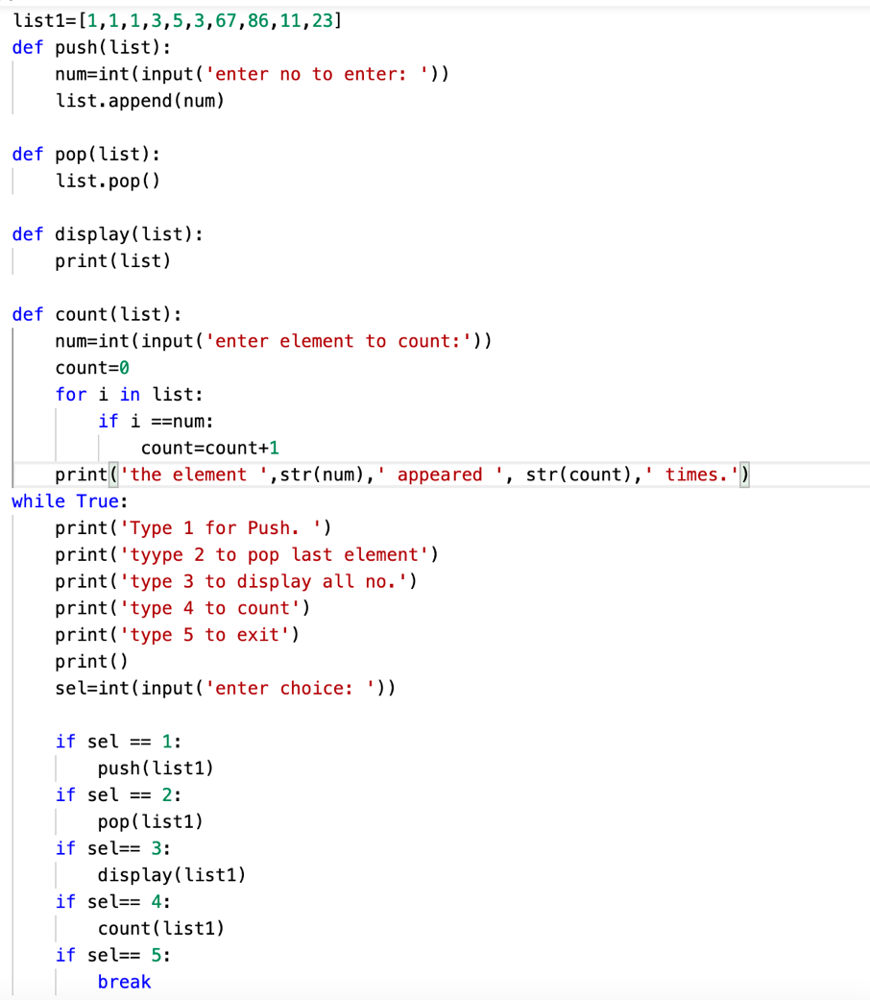

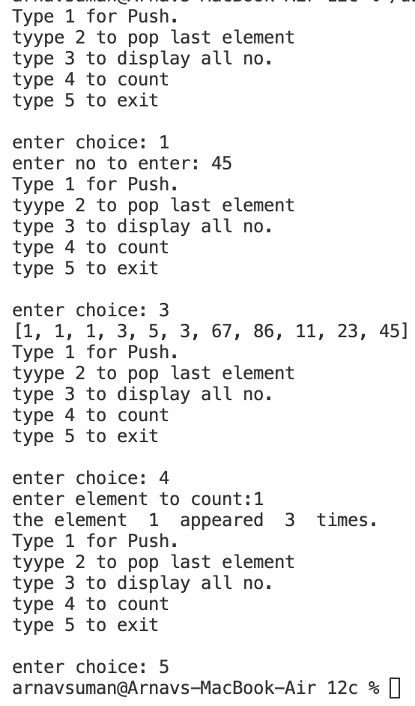

**PRACTICAL 45**

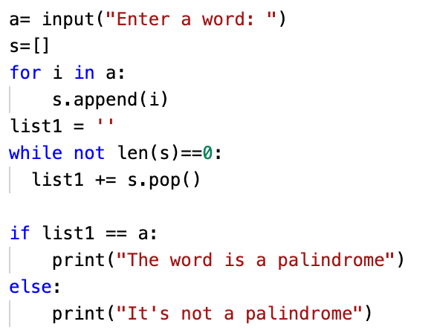

**OUTPUT**

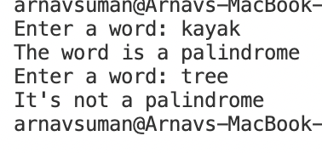

**PRACTICAL 46**

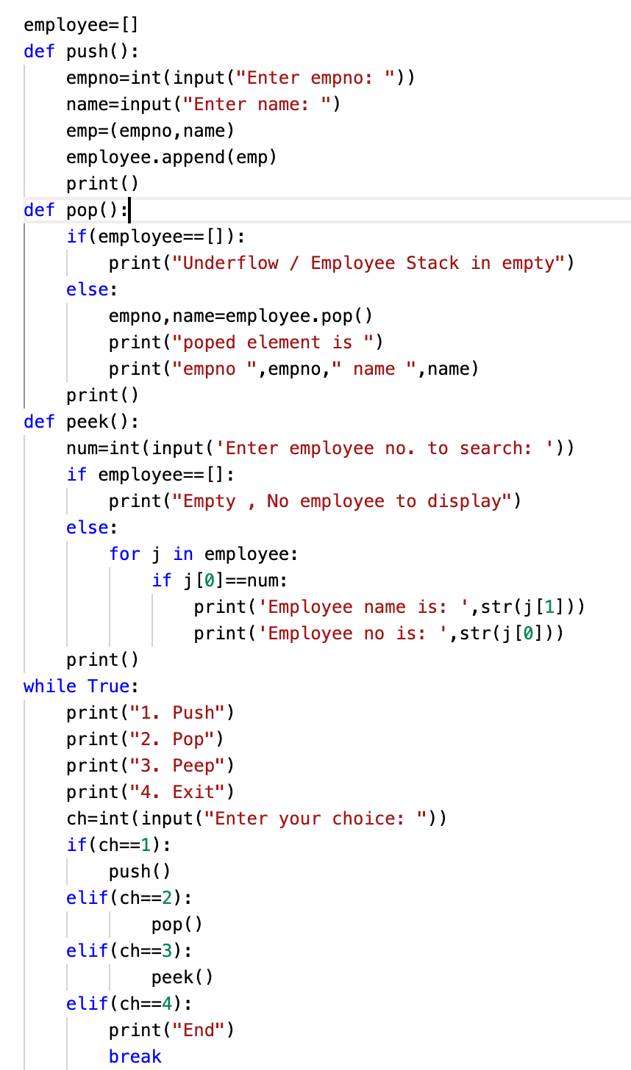

**OUTPUT**

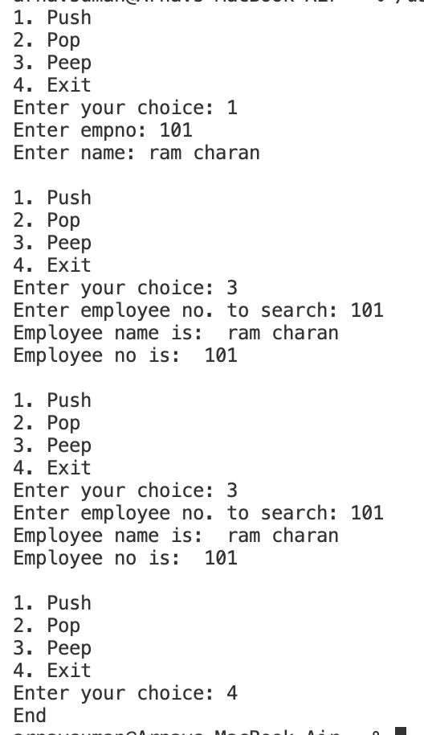

**PRACTICAL 47**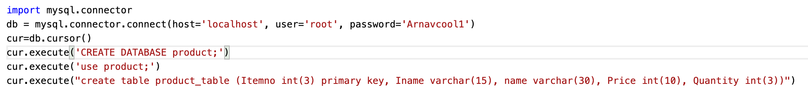

**OUTPUT**

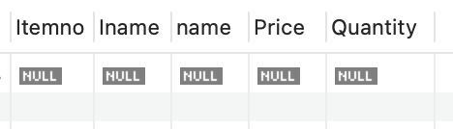

**PRACTICAL 48**

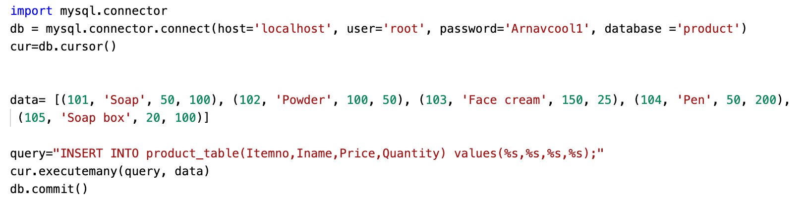

**OUTPUT**

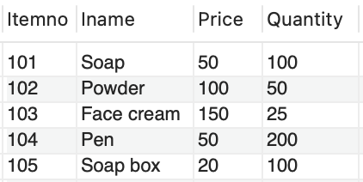

**PRACTICAL 49**

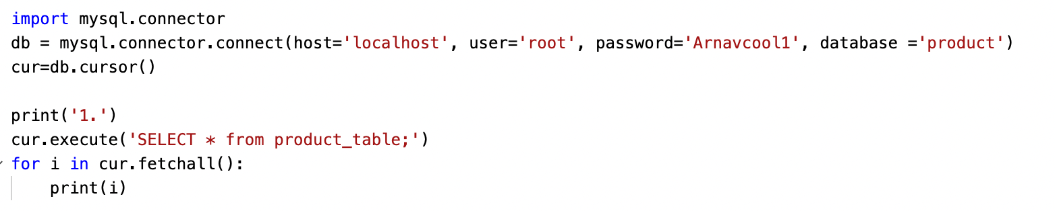

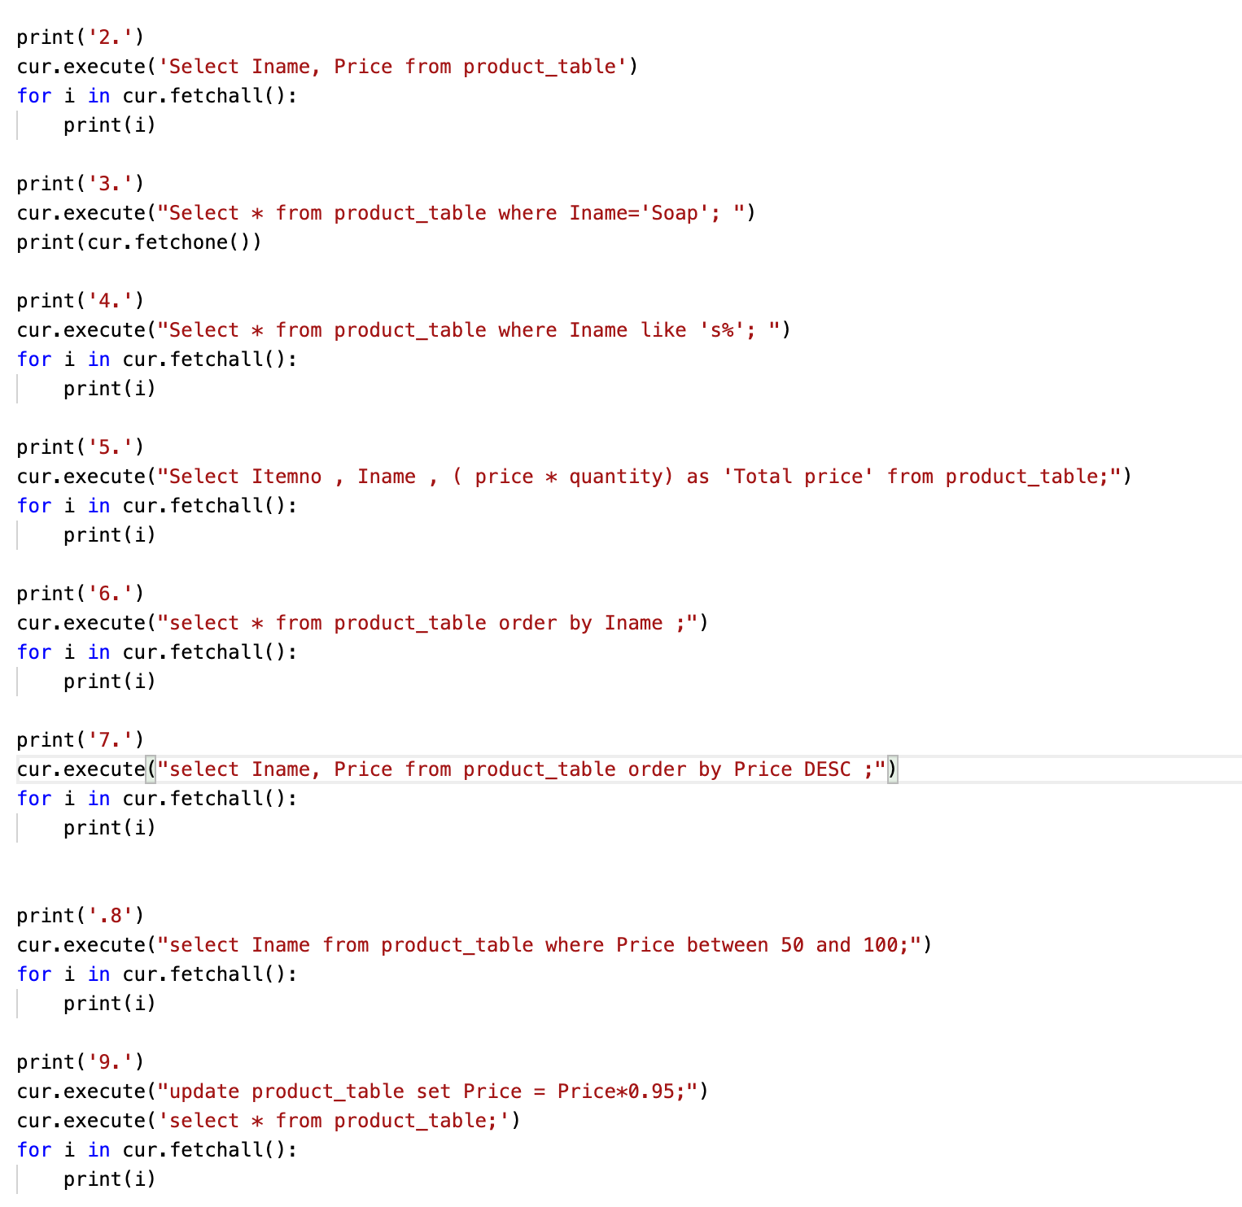

**OUTPUT**

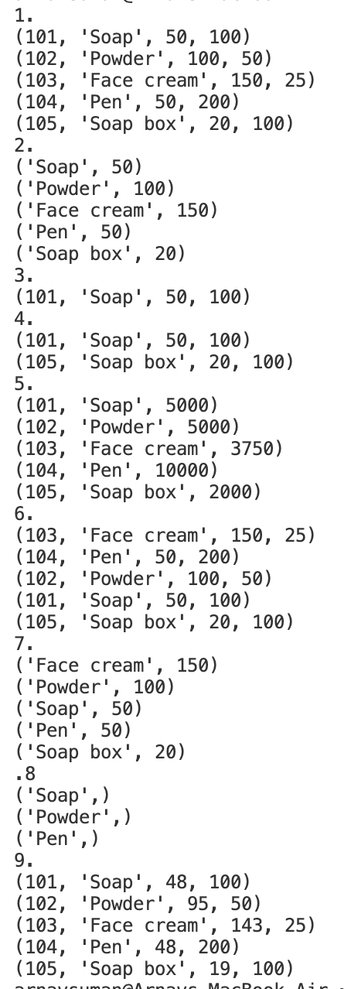

**PRACTICAL 50**

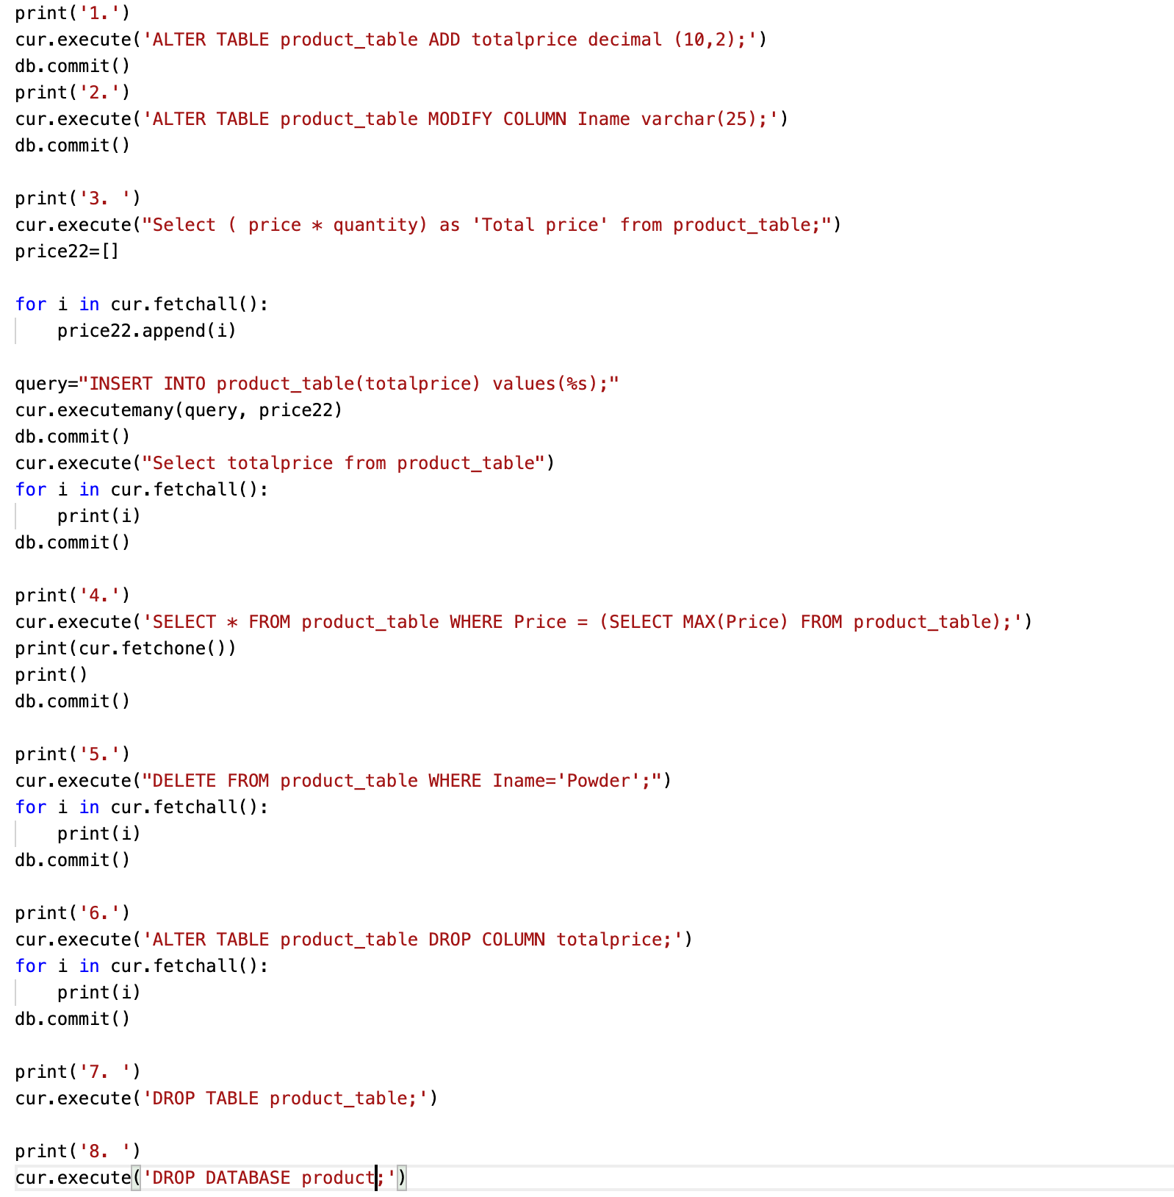

**PRACTICAL 51 OUTPUTS**

**1.**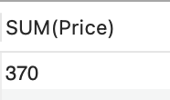

**2.**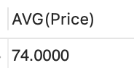

**3.**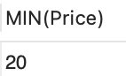

**4.**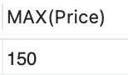

**5.**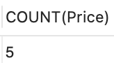

**6.**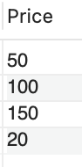

**7.**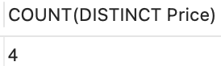

**8.**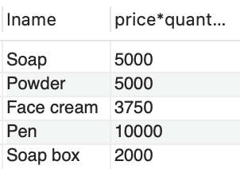

**PRACTICAL 52**

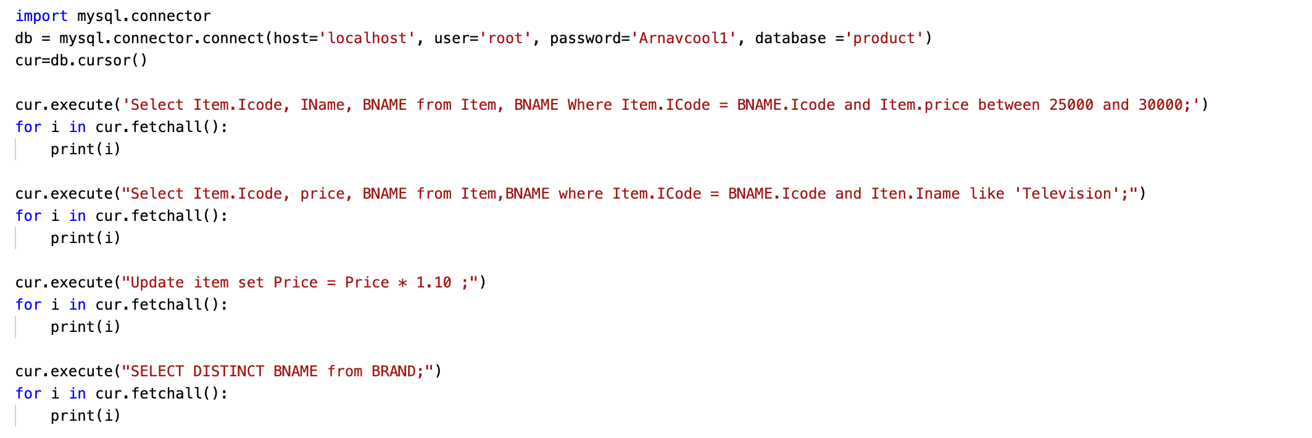

**PRACTICAL 53**

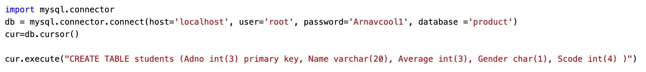

**OUTPUT**

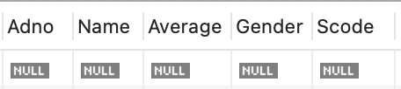

**PRACTICAL 54**

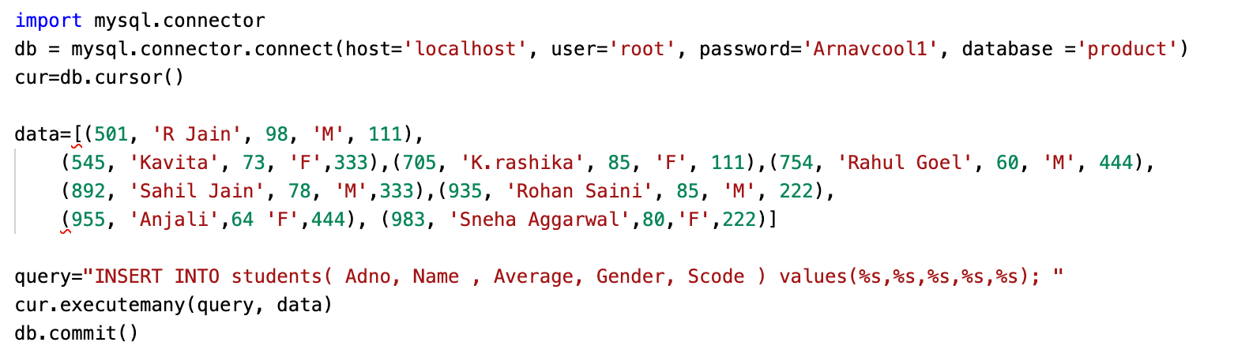

**OUTPUT**

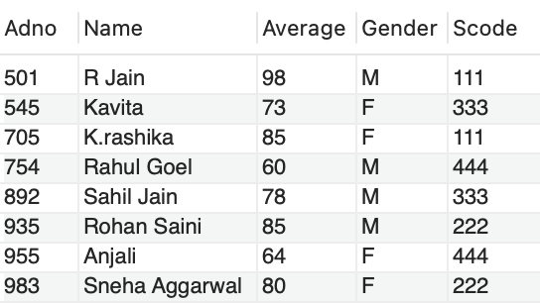

**PRACTICAL 55**

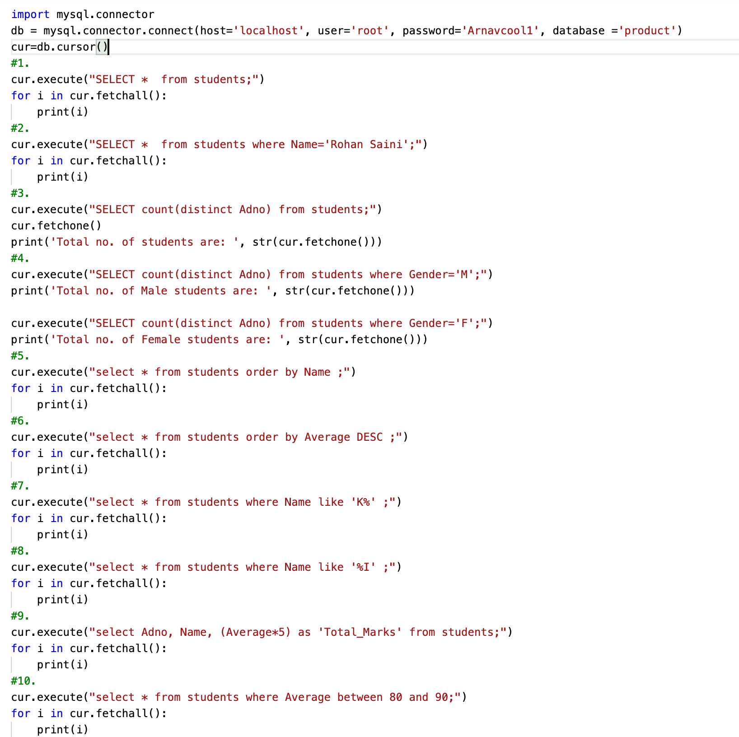

**OUTPUT**

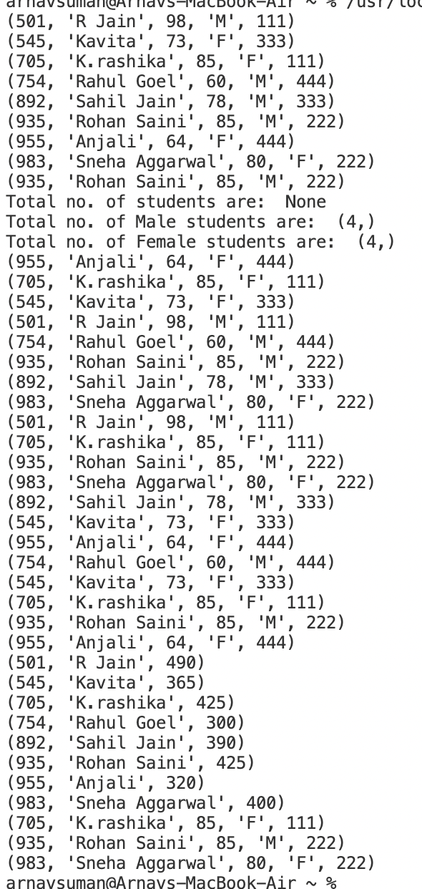

**PRACTICAL 56**

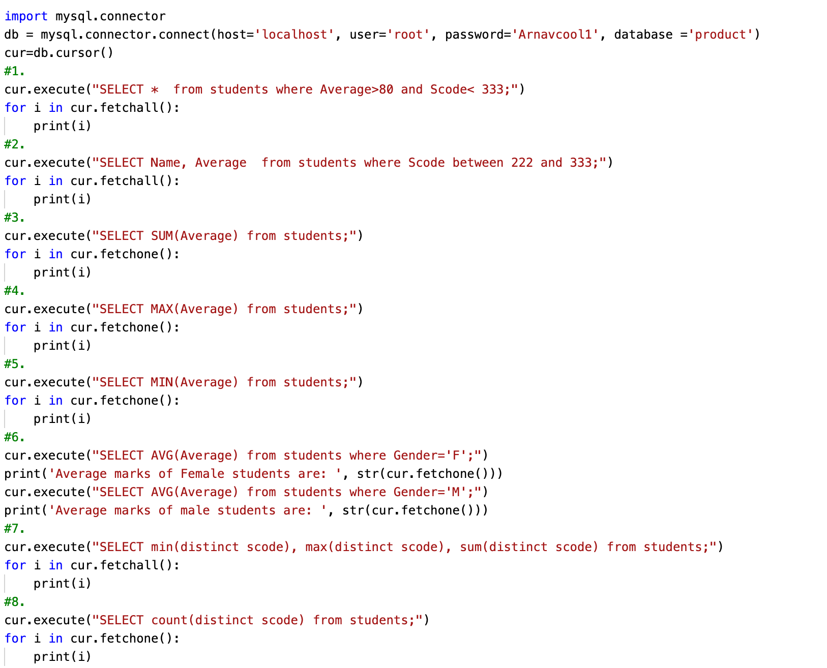

**OUTPUT**

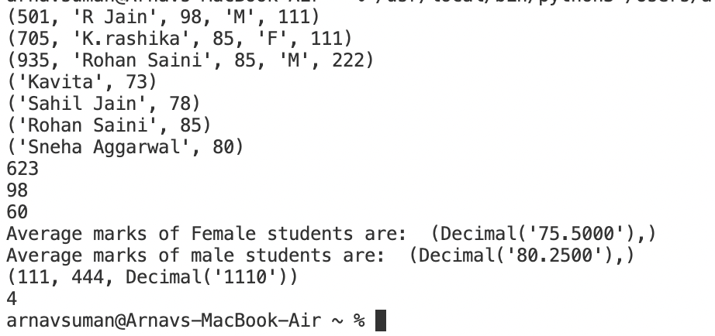

**PRACTICAL 57**

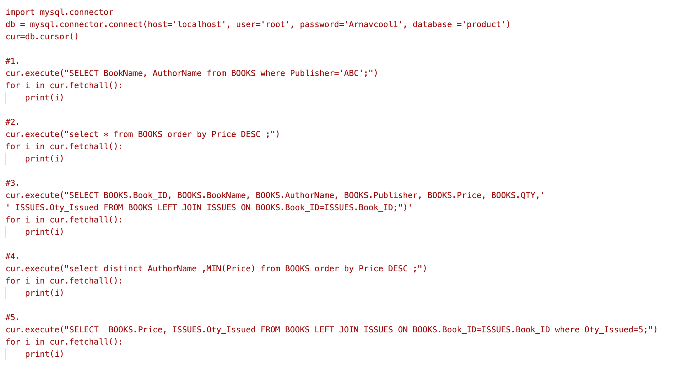



**PRACTICAL 58**

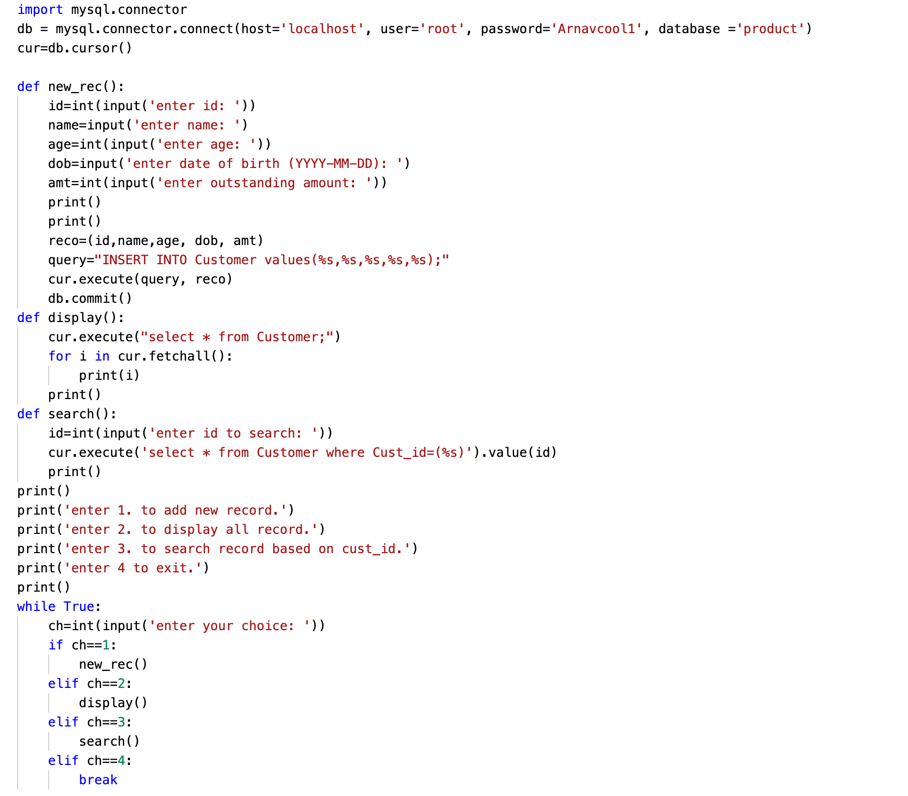

**PRACTICAL 59**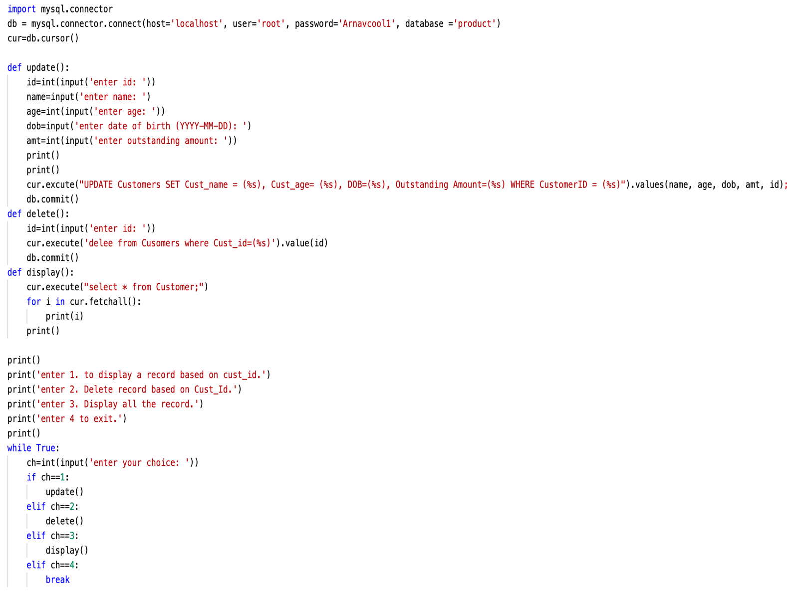

**PRACTICAL 60**

